Homework 8: 100 Points
This Homework contains examples of multiprocessors and cache coherency.
Please submit your answers in a document and upload it in Canvas by the due date.
Present your work neat, clear, organized, logical, and make your case; don’t leave it to our interpretation of your answer. There is 10% penalty per day for delay in submitting the homework.
- 6.1 a, b (20 points each)
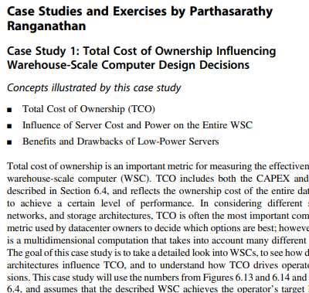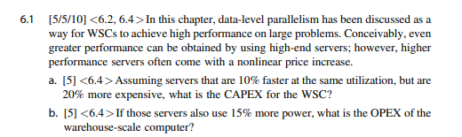
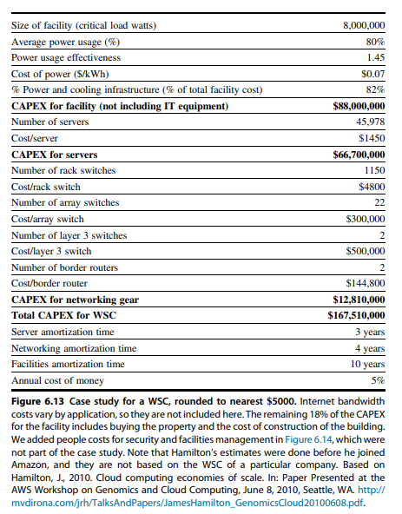
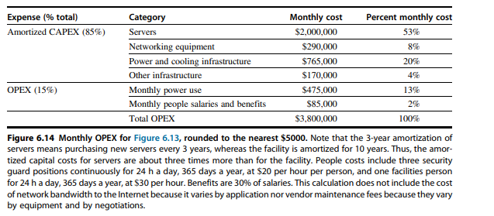
a. New Server Cost= 1450 * (1+0.2)= $1740 per server
CAPEX= $79,990,920

b. OPEX Old Servers= $475,000 per month
OPEX New Servers= 475000*(1+0.15)= $546,250 per month

- 6.3 a (20 points)
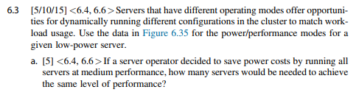
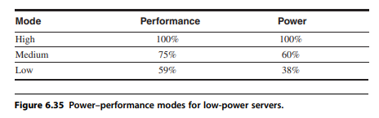
Performance-High= 100
Performance-Medium=75
$Number of Servers= \frac{100}{75}=1.33$ (Rounded up to 2)
To achieve the same level of performance, you would need 2 medium performance servers to achieve the same level of performance as a high performance server.

- 6.14 a (40 points)
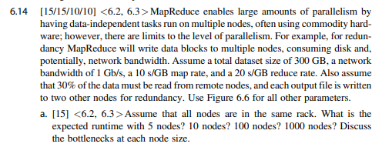
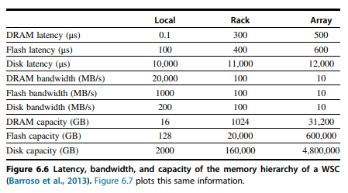
5 Bodes
Map Time= 10*300= 3,000 seconds (or 50 minutes)
$Remote Transfer Time=\frac{90 GB}{0.125 GB/s}=720 seconds$ (or 12 minutes)
$Write Transfer Time=\frac{900 GB}{0.125 GB/s}=7200 seconds$ (or 120 minutes)
Total Runtime= 50+12+120= 182 minutes for 5 nodes

10 Bodes
Map Time= 10*300= 3,000 seconds (or 50 minutes)
$Remote Transfer Time=1/2*\frac{90 GB}{0.125 GB/s}=360 seconds$ (or 6 minutes)
$Write Transfer Time=\frac{900 GB}{0.125 GB/s}=7200 seconds$ (or 120 minutes)
Total Runtime= 50+6+120= 176 minutes for 10 nodes

100 Bodes
Map Time= 10*300= 3,000 seconds (or 50 minutes)
$Remote Transfer Time=1/10*\frac{90 GB}{0.125 GB/s}=72 seconds$ (or 1.2 minutes)
$Write Transfer Time=\frac{900 GB}{0.125 GB/s}=7200 seconds$ (or 120 minutes)
Total Runtime= 50+1.2+120= 171.2 minutes for 100 nodes

1000 Bodes
Map Time= 10*300= 3,000 seconds (or 50 minutes)
$Remote Transfer Time=1/100*\frac{90 GB}{0.125 GB/s}=7.2 seconds$ (or 0.12 minutes)
$Write Transfer Time=\frac{900 GB}{0.125 GB/s}=7200 seconds$ (or 120 minutes)
Total Runtime= 50+0.12+120= 170.12 minutes for 1000 nodes

